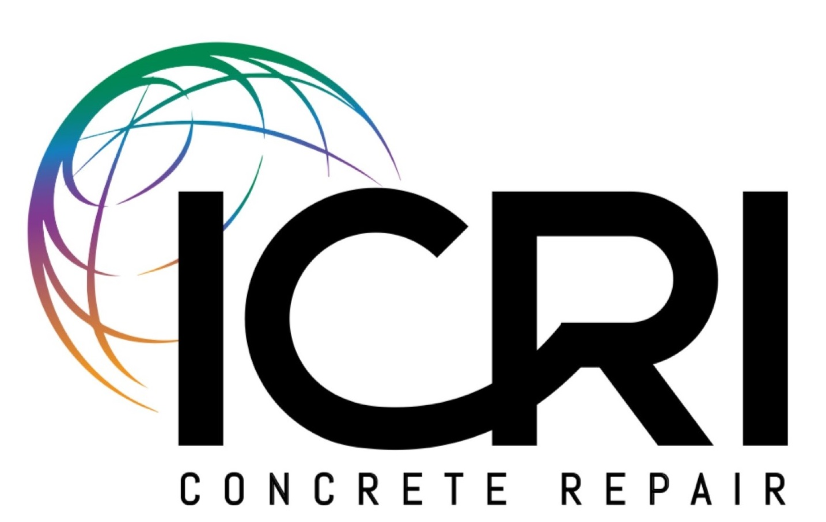
ICRI Regional Representation - 2020
All ICRI Chapters are part of a Region. Below is a list of all the ICRI Regions, the chapters included in each Region and the Director on the ICRI Board that is from that Region.

Region 1: Geographic Coverage: Florida, The Islands, South America, Puerto Rico
ICRI Chapters Included: Central Florida (CFL), Florida First Coast (FFC), Florida West Coast (FWC), Southeast Florida (SFL), and Southwest Florida (SWF)
Regional Rep: Ingrid Rodriguez (2020), Ingrid Shawn Corporation

Region 2: Geographic Coverage: Georgia, Alabama, North Carolina, South Carolina,
Southern Virginia, Mississippi, Louisiana
ICRI Chapters Included: Georgia (GA), Carolinas (CAR), Virginia (VA), Gulf South (GS)
Regional Rep: Paul Farrell (2019), Carolina Restoration & Waterproofing, Inc.

Region 3: Geographic Coverage: Northern Virginia, Maryland, Eastern Pennsylvania,
Delaware, Southern New Jersey
ICRI Chapters Included: Baltimore-Washington (BWC), Delaware Valley (DV)
Regional Rep: Pat Gallagher (2021), Pullman

Region 4: Geographic Coverage: Northern New Jersey, New York, Connecticut, Vermont,
New Hampshire, Massachusetts, Rhode Island, Maine, Eastern Canada
ICRI Chapters Included: Metro New York (MNY), Connecticut (CT), New England (NE), Quebec Province (QP), Toronto (TOR)
Regional Rep: Kevin Robertson (2020), King Packaged Materials Co.

Region 5: Geographic Coverage: Iowa, Illinois, Missouri, Kansas
ICRI Chapters Included: Chicago (CHI), Great Plains (GP), Iowa/Illinois (I/I) Regional Representative: Jon Connealy (2019), Logan Contractors Supply, Inc.

Page 12
Region 6: Geographic Coverage: Western New York, Western Pennsylvania, Ohio, West
Virginia, Kentucky, Tennessee
ICRI Chapters Included: Northern Ohio (NOH), Pittsburgh (PIT), Greater Cincinnati (GCC), Central Ohio (COH), and Mid-South (MDS)
Regional Representative: David Marofsky (2021), MAPEI Corporation

Region 7: Geographic Coverage: Colorado, Texas, Oklahoma, Arkansas, North Dakota,
South Dakota, Nebraska
ICRI Chapters Included: Rocky Mountain (RM), North Texas (NTX),
Houston (HOU), South Central Texas (SCT)
Regional Representative: Pete Haveron (2020), Texas Concrete Restoration, Inc.

Region 8: Geographic Coverage: Washington, Oregon, Western Canada, California, Idaho,
Montana, Wyoming, Alaska, Nevada, Utah, Arizona, New Mexico, Hawaii,
ICRI Chapters Included: Northern California (NCA), British Columbia (BCC), Pacific Northwest (PNW), Southern California (SCA) Arizona (AZ)
Regional Representative: Dennis Wipf (2022), Gervasio & Associates, Inc.

Region 9: Geographic Coverage: Minnesota, Wisconsin, Michigan, Indiana
ICRI Chapters Included: Minnesota (MIN), Michigan (MI), Indiana (IND)
Regional Representative: Dan Wald (2021), BASF Construction Systems

Regional Representative Duties
The Regional Representative is elected by a Region to represent that region on the ICRI Board of Directors. After garnering consensus amongst the chapters in that region, the Representative should maintain communication with the leadership of the chapters in that Region to the best of the Representative’s abilities. Leaders should reach out to the Representative if there are questions, issues, or concerns not currently being addressed by ICRI.
- Ensure each chapter in your region has your current contact information.
- Maintain consistent communication with leaders in your region throughout the year, including submission of articles of Chapter events, and calendar items for upcoming Chapter events for inclusion in the CRB
- Request that they copy you on all correspondence with ICRI National.
- Communicate with Chapter Presidents and assist them as needed in completing the Annual Chapter Award or Annual Report forms.
Page 13
- Prior to each ICRI Convention, communicate with Chapter leaders regarding the Chapter Delegate program, with emphasis on the requirements for the Delegates to attend BOTH the Inter-Chapter Luncheon AND the Chapters Committee meeting on the last day of the convention.
- Attend the Regional Roundtable meetings when they are held in your area, and strongly encourage Chapter leaders to send two participants to the meetings.
- Travel to each chapter in your region and participation in their events is strongly encouraged.
- Attend the three in-person Board of Director meetings: at World of Concrete, at the ICRI Spring Convention and at the ICRI Fall Convention.
- Participate in the monthly Board of Director conference calls.
- Report to each Chapter President in your Region within 2 weeks to 30 days maximum after an ICRI Board Meeting.

I, _______________________________ hereby agree to abide by these requirements as a
(Printed Name)
member of ICRI’s Board of Directors.

______________________________ ________________________
Signature Date

Page 14

