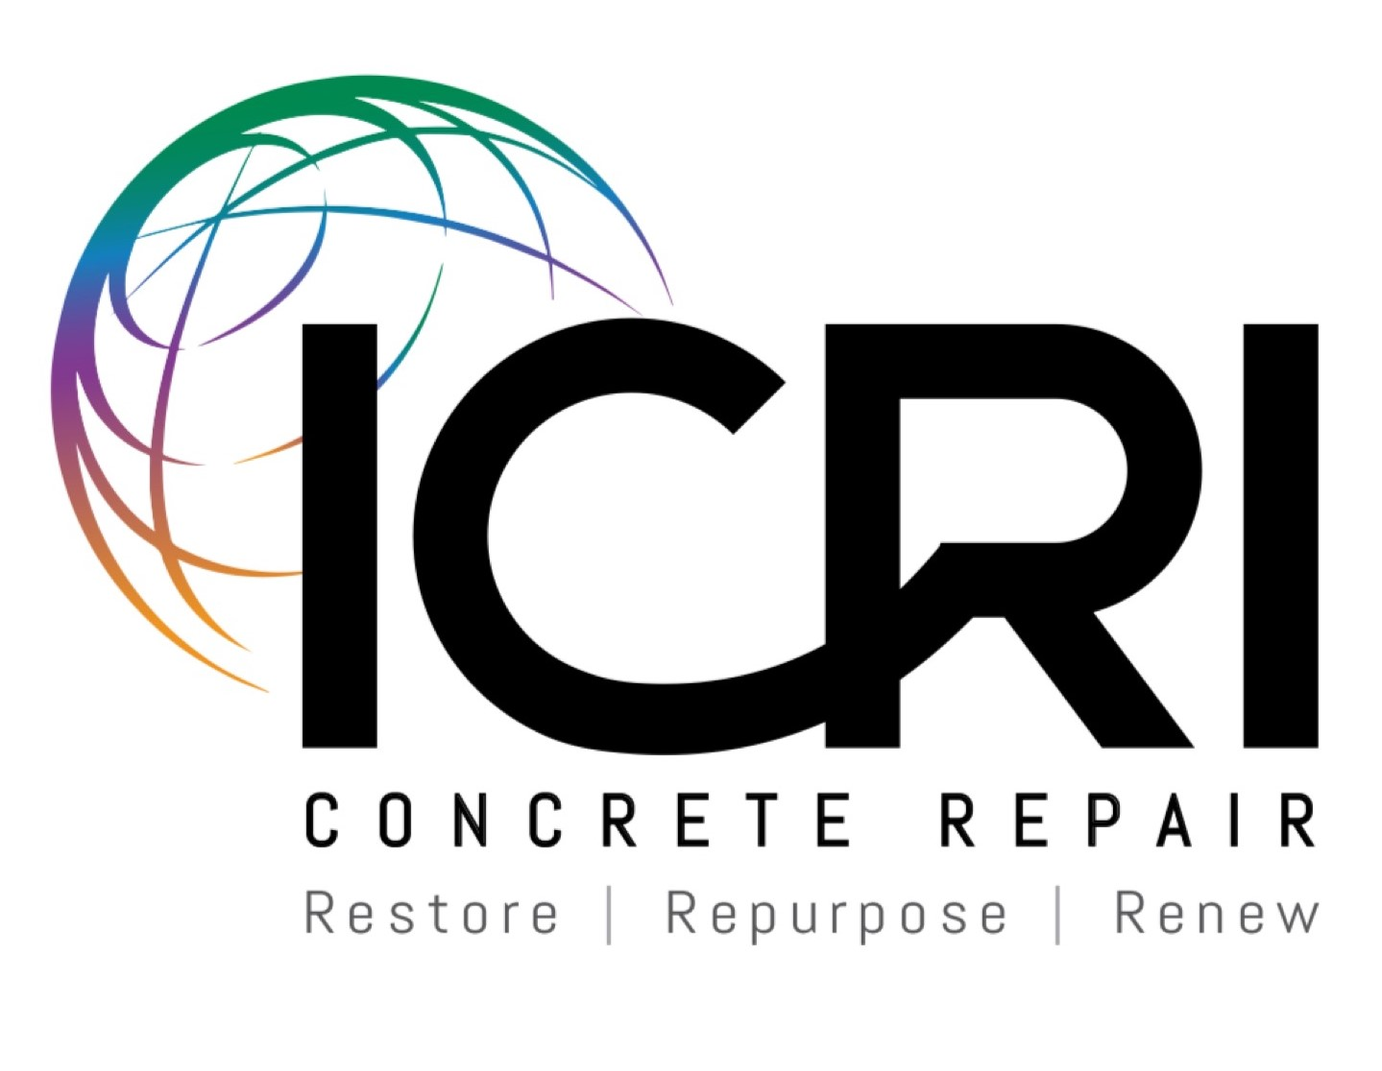

ICRI Chapter Organization Guide and Policies

2019

Introduction
The ICRI Chapter Organization Guide and Policies is a guide for existing and start-up chapters to use to facilitate and manage their chapters according to policies set forth by the ICRI Chapter Committee and ICRI board.

Using this guide, any person or persons will have a step-by-step guide and the necessary tools for starting a chapter in their area. Once the chapter has been chartered, the chapter should keep this guide in their chapter files and consult it regularly when questions arise regarding chapter policies.

Because this guide is a living document and will see regular updates from the Chapter Committee, revisions will be sent to all chapter officers upon approval, and the latest revision can always be found on the Chapter Officer Resources section of the ICRI Web site. Past revisions must be discarded.

If your start-up or existing chapter has recommendations for additions to the guide or policies, they should be directed to Dale Regnier, Director of Chapter Relations. All recommendations will be brought to the Chapter Committee for review.

Dale Regnier
Director of Chapter Relations
ICRI
1000 Westgate, Suite 252
St. Paul, MN 55114
651-290-6278
daler@icri.org

Starting a Local Chapter
By following the steps outlined below, as a group of like-minded repair specialists should be able to have a chapter formed and operational over a period of several weeks. ICRI staff stands ready to answer any questions you may have after reading this booklet, so please do not hesitate to call.

Step 1 - Determine Local Interest Level
It should go without saying that a chapter has little chance of success if there is not a core group of individuals willing to make it happen. However, if those individuals are all involved in the same or similar businesses, it is much less likely that others will be attracted to take part in chapter meetings and activities.

To determine the level of local interest, contact current ICRI members and any nonmember contacts you may have in your area. The ICRI office will supply a list of members and nonmembers in a given area, so long as the person is an ICRI member. Allow a relatively short response time; if persons are genuinely interested, it will not take long to gather this information.

The ICRI by-laws allow the formation of chapters in areas with at least 15-20 ICRI members. However, this is a minimal number to depend upon when trying to provide for a viable and growing organization and it is prudent to have 20-25 persons interested in forming a chapter before proceeding.

Step 2 - Hold an Initial Meeting
An initial meeting can be in one of two forms.

If there is a sufficient number of interested persons willing to act as a steering committee, and they represent several facets of industry, you can hold a meeting to determine the structure of the chapter.

The other, and probably more desirable, alternative is to hold an open meeting, to which all ICRI members and potential members are invited. To attract these people to the meeting, feature a technical presentation or panel discussion on an issue relevant to the area.

When sending the invitations, invite people interested in starting the chapter and serving as an officer to attend a meeting prior to the technical presentation meeting. You can then choose your initial officers and board based on the interest of the meeting attendees.

Following the technical meeting, introduce the proposed officers and board to the meeting attendees and tell them whom to contact if they are also interested in serving.

Step 3 - Determine the Chapter Structure
The steering committee determines a proposed structure for the chapter. The items that need to be determined are:

- Chapter name.
- Geographical boundaries.
- Frequency and types of meetings.
- Meeting location(s) (one general location or different communities within the geographic area that the chapter services).
- Chapter dues.
- By-laws. This guide includes a model by-laws. Use it to develop by-laws specific to your chapter. Because these are the rules by which your chapter will operate, it is imperative to carefully prepare them. Options are to be selected and blanks filled in to arrive at usable by-laws for chapter activities. Sections may be added or deleted as appropriate.
- List of pending officers and directors. All chapter officers must be ICRI members. Note: There is no ICRI requirement for a separate secretary and treasurer; these offices may be combined into one position if desired.
- Standing committee chairs. It is important to appoint Program and Membership Committee chairs as soon as possible.

Step 4 - Assign Officers and Directors
The chapter’s Steering Committee should make up the chapter’s first slate of officers and directors, all of whom must be ICRI members. Listing of the chapter officers on the charter, with the signatures of at least 15 local ICRI members constitutes approval of the officers.

The chapter must provide the Director of Chapter Relations a complete list of its officers and board.

Step 5 - Apply for ICRI Charter
For start-up chapters not yet chartered as official ICRI chapters, anyone wishing to participate must first join ICRI National. This guide includes a sample application for an ICRI charter. When the organization of the chapter is substantially complete, the application should be forwarded to the ICRI office.

The following must be included with the chapter charter and by-laws:

- Federal Employee ID number (EIN) or tax ID, if applicable.
- A list of upcoming events, so the committee and ICRI board can verify your activities.
- The proposed chapter by-laws.

Step 6 – Begin Regular Meetings
While the chapter is waiting for its charter to be approved, it should go on with business as usual. Holding technical dinner meetings or a social outing is a great way to generate more interest in your chapter and will show the ICRI Board that the chapter is active.

The chapter must provide event announcements and reports to the Director of Chapter Relations

Approval of ICRI Chapter Charter
Once a chapter has completed all six steps to starting a local chapter, it must submit all required documentation to ICRI. The Director of Chapter Relations will then verify that all information has been received or if there are any missing information the chapter needs to provide.

Once all documentation is in order, ICRI will send everything to the Chapter Committee Chair and the ICRI Chapters Committee for review and approval. Once accepted by the Chapters Committee, the charter will go before the Board for a vote. Once the Board approves the charter and documentation, the chapter will be chartered and can begin dues collection as an ICRI chapter. If there are any discrepancies, the chapter will be given the opportunity to make corrections and resubmit their documentation.

Once the Charter is signed, ICRI will create a Chapter page on the ICRI website where new and current members can add the new chapter to their memberships. After the Charter is signed, all current ICRI members will then be able to add the New Chapter to their Membership by calling the ICRI office.

Other Considerations

Identification Number
All chapters must apply for a Federal Employer Identification Number (EIN) or tax ID, as applicable, as soon as possible. This identification number is required to open a bank account for the chapter.

You can obtain an EIN by phoning the IRS. When applying, be sure to note that you are applying for the number for bank account use only.

Bank Account
Chapters must open a bank account in the name of the chapter ONLY. It is recommended that the Treasurer be bonded for his/her own protection as well as the chapter’s protection. ICRI will withhold all dues reimbursement checks until the chapter provides proof of establishing a bank account.

Filing for Incorporation and Non-Profit Status
Once a Chapter Charter has been granted the new chapter should file for incorporation with in their home state. The new chapter must also file for non-profit status (as a 501(c) 6 organization) with the Internal Revenue Service.

Federal Taxes
Filing a Federal Income Tax form (the non-profit form is #990 or #990N) is required for all chapters annually.

Literature
The new chapter will be supplied with reasonable quantities of promotional literature about ICRI, including issues of Concrete Repair Bulletin, membership applications, ICRI brochures, etc. The value of these items is not used in determining the chapter's initial reimbursement. ICRI will also assist in preparing and mailing notices of organizational meetings, again at no charge.

Chapter Supplies
The purchase of stationery and other supplies is the responsibility of the local chapter. ICRI can provide the logo to the chapter or start-up chapter upon request.

Representation
The chapter’s officers and members must not represent themselves as being the International organization or agents of the International organization. The chapter letterhead and other chapter publications must take this into account, and the chapter name must appear in larger type than the ICRI name. It must be clear to anyone receiving chapter correspondence that the material is from the chapter and not ICRI International.

ICRI Policies for Chapter Operations
There are several ICRI policies that relate to the start-up and operation of local chapters. These policies will be updated regularly, as new ones are instituted. For a current list of policies, visit the Chapter Resources page of the ICRI website, or call 847-827-0830.

Membership
A person or firm must be a member of ICRI in order to be a member of a local chapter.

Chapter Officer Membership According to all chapter Bylaws, in order for someone to serve as an officer or director for a chapter, that person must be a member of both ICRI and the local chapter.

ICRI will periodically send notices to chapter officers, listing their paid and unpaid officers and board members. For those who have not paid dues, ICRI will recommend the chapter elect a new officer or board member to replace that person. ICRI will give the chapter 30 days to either have the board member/officer pay their dues or elect a dues-paying member to replace that person.

Failure to comply may lead to the chapter’s charter being revoked.

Chapter Officer and Board Installation Date
The installation date for all ICRI chapter officers and directors is January 1. Chapters can hold elections at a time that works best for them, but all officers and board members will have the same installation date, January 1. All chapters are required to provide a complete list of all ICRI Officers and Directors for the coming year by January 15th of each year.

Dues Collection
All ICRI and chapter dues must be sent to the ICRI International office and not collected by a local chapter. ICRI will send the chapter secretary a dues reimbursement check each month the chapter has new and renewing members with a list of those members.
Insurance
Normal chapter operations are insured under the blanket ICRI liability policy. Each chapter has a letter from ICRI International’s insurance provider, explaining the chapter’s insurance policy. If your chapter needs a copy of this letter, please contact the ICRI International office.

Chapter Start-Up Cost Reimbursement
ICRI will reimburse local chapters up to $400 for miscellaneous start-up expenses such as postage, printing, etc. These payments are made promptly upon receipt by the ICRI office of copies of paid invoices or receipts, and it is felt that these advance expenditures will not constitute a severe hardship on the local organizers. Please contact the ICRI office with any questions regarding initial funds.

Chapters Access to ICRI Brochures
ICRI will provide each chapter 100 ICRI four-color brochures each year, should the chapter need stock. If the chapter wishes to acquire more than 100 in any year, the chapter can purchase extra brochures for $75 per 100, to cover printing costs.

Charging Chapter Delegates
Elected chapter delegates of any ICRI convention are required to attend certain meetings and other criteria set forth on the Chapter Delegate Registration Information. If the delegate fails to comply with the rules, ICRI will invoice the chapter for the full registration fee.

To ensure the delegate and chapter officers are aware of this responsibility, ICRI will send a letter to the delegate and the chapter officers, reminding them of this policy. If the delegate cannot comply, substitute attendees from the same chapter – on a case-by-case basis – can be proposed to the Chapter Committee Chair and Director of Chapter Relations. This must be done prior to the meeting.

Chapter Annual Reports
Each chapter is required to file an annual report with ICRI no later than February 15th of each year. The purpose of this report is to summarize the chapter's activities for the year, list its current officers and directors and provide a financial report as required by the ICRI by-laws.

The failure to submit this very important report may result in the withholding of chapters dues reimbursement checks by ICRI.

Chapter Roundtable Program
Each chapter will have the opportunity to attend one Chapter Roundtable event once every two years. Each chapter will be part of a chapter area, including up to nine other chapters, who will all participate in the Roundtable event. The Chapters Committee suggests that each chapter send at least two representatives (current or future leaders). The ICRI President, Chapters Committee Chair, Regional Representatives from the appropriate Regions, and other available Board members will also attend. ICRI will send the Chapter Relations Director, Executive Director, and Technical Director to help chapters with ICRI National initiatives. Chapters will learn and share with each other successes and challenges and will receive practical tips and best practice knowledge from each other, ICRI Leadership, and ICRI staff members. Chapters will send representatives to a regionally beneficial location and help with transportations and hotel stay. ICRI will provide the meeting space, meals during the event.

Inactive Chapter Protocol
If a chapter has not had any activity in at least six months, the Director of Chapter Relations reports the chapter to the Chapters Committee. ICRI will report on communications had with the chapter, including unreturned phone calls, e-mails, etc.

The Chapters Committee Chair will contact the chapter officers and board members via letter and a follow-up phone call, informing them that the committee is concerned with their lack of activity and that the chapter may have its charter revoked.

The letter will establish a time line of goals the committee would like the chapter to achieve.

If the chapter still hasn't met the Chapter Committee’s goals by the set deadline, the ICRI president will send a letter to all of the chapter’s members, giving them an extended deadline to fulfill the committee's requirements.

If the chapter members do not meet all of the established goals by the extended deadline, the ICRI board has the right to revoke the chapter’s charter.

Chapter Sponsorship and Co-Sponsorship of Events at ICRI Conventions
If a local chapter wants to hold an event in conjunction with an ICRI convention, ICRI headquarters must approve, in writing, the entire event plan before it can be publicized or finalized.

If a local chapter wants to sponsor or cosponsor an event (e.g., social outing, Welcoming Reception) at an ICRI convention or Annual Meeting, the chapter must conform to the following guidelines.

Full Sponsorship – The chapter pays the TOTAL cost of the event. If the chapter wants to get local business sponsors, it must get the approval of ICRI.

Co-Sponsorship – In the case of co-sponsorship, such as contributing to the Welcoming Reception at an ICRI convention, the chapter pays an agreed upon amount. The chapter must commit to the sponsorship in writing. All sponsors will be recognized.

Host Chapters Promoting Conventions to Local Colleges
Chapters hosting ICRI conventions, even if they are not planning a special event, need to contact local colleges and universities with concrete or concrete repair programs to promote the convention. Chapters are encouraged, but not required, to sponsor one or more students to attend the convention.

PETITION FORM TO APPLY FOR CHARTER AS A LOCAL ICRI CHAPTER

The undersigned hereby petition the International Concrete Repair Institute to grant a charter for the establishment of a local chapter in the following geographic area:

_____________________________________________________________________

which we propose to name the _____________________________________________________ Chapter of the International Concrete Repair Institute.

Please ensure you comply with each of the following criteria – check them off as you complete each.

- We agree to adopt by-laws consistent with the by-laws of the Institute, and to operate the chapter in accordance with the principles and policies of the Institute. Modified sample By-Laws are attached.

- We have set the new chapter dues to be $ ______________ US Dollars per year. (Chapter dues cannot exceed 50% of the lowest ICRI National Membership dues of $130).

- We have applied for and received the following EIN: ____________________________ a Federal Employee ID number (EIN) from the US Government or other entity as prescribed by law.

- We have opened a bank account in the name of the Chapter. BANK ____________________________
Local Branch Address: ___________________________________________________________________
ACCOUNT NUMBER:________________________ ROUTING NUMBER ________________________.
Please attach a cancelled check with the other documentation.

- We have a plan for the first year of operation with potential meeting dates, types, and topics.

The following have agreed to serve as the initial officers of the chapter:

President (PRINTED NAME) | COMPANY
Vice-President (PRINTED NAME) | COMPANY
Secretary (PRINTED NAME) | COMPANY
Treasurer (PRINTED NAME) | COMPANY

-- CONTINUED ON NEXT PAGE --

-- CONTINUED FROM PREVIOUS PAGE --

This petition is made on this ___________ day of __________________, 20______ by the following members in good standing of the International Concrete Repair Institute: Note: There must be at least three different categories of membership represented among the 15 required signers.

Name | Company | Signature
1.
2.
3.
4.
5.
6.
7.
8.
9.
10.
11.
12.
13.
14.
15.

Attest:

President Designee |  | Secretary Designee |  | Treasurer Designee |  | Date

