Membership Recruitment Guide
Purpose
The purpose of this document is to provide a guideline to help focus the efforts of chapters in growing their membership, which in turn increases the size of the overall association. Chapters can have a larger and more personal impact on local companies and individuals when soliciting membership. In turn, more companies and individuals as members of ICRI provides positive effects on all four of the strategic pillars.
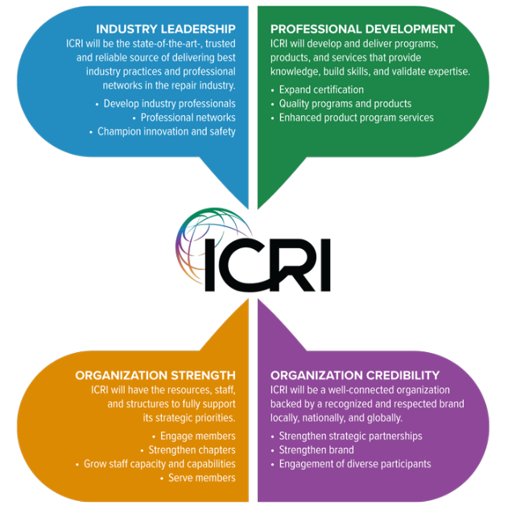

Membership Recruiting
Meetings:
Many chapters report that many non-member individuals attend meetings and activities. It should be the goal of the board of directors (BoD) to identify these people, make them feel welcome, and seek their commitment to join the association.
Strategies
- Meetings and events should have member and non-member rates. The non-member rates should be increased by enough of a margin to encourage signing up as a member.
  - Recommendation to increase the non-member rate for chapter events by 25%, 50% or 100%.
  - One method for the calculation is to determine the cost of membership and divide by the number of events. This shows an ROI to join.
    - Example: Georgia Chapter – National individual membership is $200 plus $40 for the chapter dues divided by the total number of meetings of 10 = a $24 delta (or more) between member and non-member rates will be a reason to join.
- Member or non-member should be tracked for each meeting attendee to allow the membership committee and the BoD to recruit the non-members to join.
- Membership committee and BoD should position themselves at the registration table to specifically welcome new members and non-members and encourage them to participate or to join (respectively)
- ID badges for meetings should have flags or tags to identify new members, non-members, first time attendees, students, etc. This allows for more member participation with them.
- The President or Board member who is making the introduction to the meeting should identify the BoD, first time attendees, new members and non-members (ask for hands or to stand) at the start of the meeting.
- The President should ask for non-members to join and provide information and resources for them to sign up at the meeting.
- After every meeting, someone should follow up with non members who attended the meeting to thank them for attending and to ask them to join the association (and the chapter).
Chapter Membership Committee
Each chapter should have a membership committee with a chair. The goal of this committee is simply to increase membership in the chapter.
Strategies
- Utilize the chapter update emails sent monthly by the management company to identify and contact new members (in blue on the spreadsheet), recently expired members (in yellow on the spreadsheet),
- Develop a list of prospecting targets for chapter membership. The list can consist of:
  - Companies in related fields (engineers, contractors, material suppliers and distributers)
  - Additional individuals in member companies
  - Students of local universities and trade schools/high schools
- The membership committee should meet more regularly than at BoD meetings. Monthly conference calls are suggested with the purpose of identifying targets to call/email, assign responsibility for the call/email, and to hold committee members accountable for their commitments. Make sure to have fun and celebrate successes!
Other Ideas
- Add other associations to eblast lists and social media that announce ICRI activities
- Hold an orientation meeting for non-members before or in conjunction with a regular meeting. Provide information about the benefits of the association and membership
- Hold a special first timers or new members event as a portion of a dinner meeting or as a special event.
- Organize specific members only events such as educational meetings or tours, go carts, skeet shooting, axe throwing, Top Golf, etc.
- Ensure that the membership committee and the BoD have an understanding of the benefits of membership and resources to describe membership as well as to allow interested members to sign up for ICRI. The easier it is to sign up, the more likely interested candidates will be to convert to members.
- When marketing to non-members, provide a clear and concise list of member benefits so they understand what THEY are getting with an ICRI membership.
- Utilize the membership coordinator with the management company. Currently in transition with Ewald. More information will be provided soon on who the membership contact will be.

